**Cucumber report generation using Extent Report Cucumber 4 Adapter**

First copy maven dependency and paste in Pom.xml

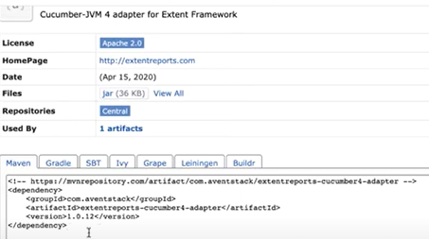

In testRunnerclass.java file, Add plugin like below.

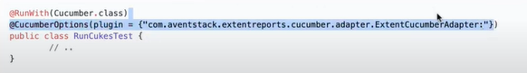

Next step is adding **extent.properties** file and add in to your **src/test/resource** folder.

In Extent properties file, contains configurations and path for output report file.

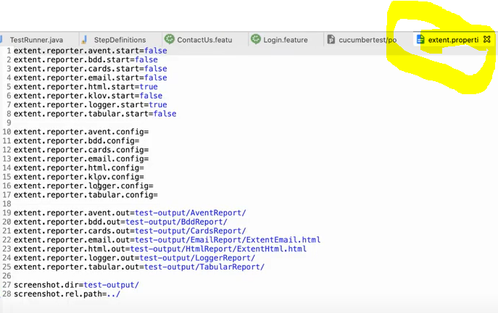

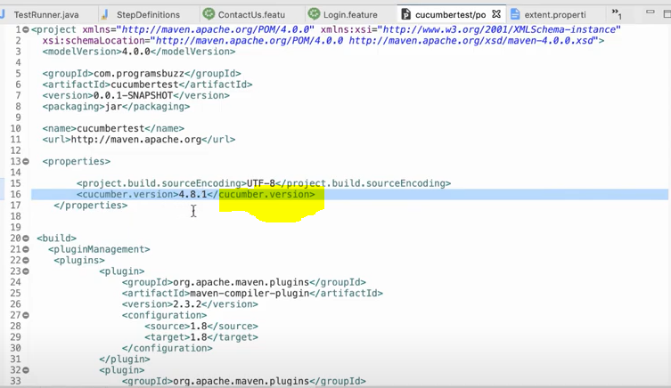

After pom.xml-🡪 run as --- > maven test…

After **Build success** output file is created

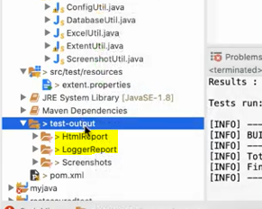 

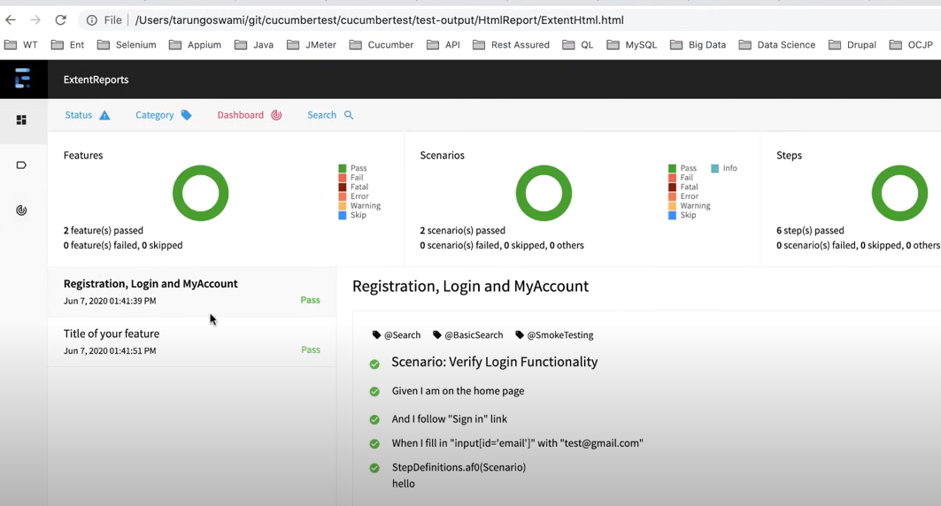

Tag based report

